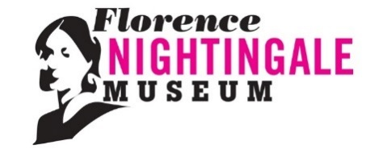
Youth Engagement Volunteer
Are you aged between 14-19 and have an interest in history and/or museums? Would you like to be part of an innovative international research project? If so, we’d love to hear from you!
The Florence Nightingale museum is recruiting youth engagement volunteers as part of an international research project working with young people. Applications are invited from anyone aged 14-19 who has an interest in history, museums and heritage and/or supporting the Lambeth and Southwark communities.

Who are we?

The Florence Nightingale Museum celebrates the life and work of the world’s most famous nurse. Located on the banks of the river Thames opposite the Houses of Parliament, the museum attracts visitors from around the world who want to learn more about the ‘Lady with the Lamp’ and her Victorian world. We also examine Florence’s legacy and her influence on nursing today.

Who are we looking for?

As part of an international research project studying young people and their engagement with the STEM subjects (Science, Technology, Engineering and Maths), we’re looking to recruit youth engagement volunteers who can bring energy and enthusiasm to the Museum and who want to gain skills in visitor engagement and museum education work. Having the following skills and interests would be beneficial:

- An interest in museums, heritage, culture, history or tourism.
- An interest in creating events and content for young people
- Ability to work as part of a team and participate in group discussion
- Aged between 14-19
- Willingness to participate in a research project and complete occasional surveys provided by the University of Exeter.

What our youth engagement volunteers will do:

- Co-create and deliver talks and tours in the museum and online
- Run object-handling stations for visitors
- Organise and run events for other young people
- Help with social media, marketing and promoting the museum to young people
- Share ideas and discuss current issues
- Learn about working in a museum
- Gain CV-boosting experience and new practical skills
- Learn about Florence Nightingale, her legacy and the history of nursing

What experience do you need?

There is no experience necessary! All we ask for is enthusiasm and commitment.

How do I apply?
If you are interested in becoming a Youth Engagement Volunteer at the Florence Nightingale Museum, please email Holly Henry at Hollyh@florence-nightingale.co.uk

Next induction
Introduction to volunteering at the museum
Sunday 20th September 12:00 -15:00
To register email hollyh@florence-nightingale.co.uk

In line with UK Government advice and guidance we have implemented safety measures in the museum. Sanitising stations and wipes are in place and masks and gloves are available. Masks are required to be worn when in the museum area. We will observe 2 meters social distance at all times.

