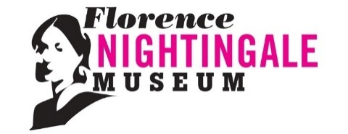
Florence Nightingale Volunteer Expression of Interest Form
– Film & Audio Production, Military Nursing Exhibition
The Florence Nightingale Museum is looking to recruit volunteers to assist with the filming / audio recording of interviews for the new Military Nursing exhibition. Referring to the role description, please answer the following questions.

Contact Details
First Name
Surname
Email
Home Address
Contact number

Briefly explain what you hope to gain from volunteering in this role (e.g. skills, meet new people etc.)

Briefly outline any experience, skills, personal qualities, or knowledge relevant to the role.

How did you hear about this role?

Thank you for your interest in volunteering with the Florence Nightingale Museum. Please send your expression of interest form to: morgan@florence-nightingale.co.uk

The information which you give on this form will be used in line with the Data Protection Act 1998. It will be used to enable the application to be processed. The information will be kept securely and will be kept no longer than necessary.

