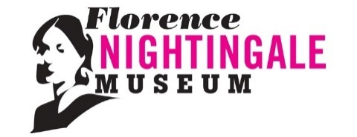
Florence Nightingale Museum Expression of Interest –
Volunteer Interview Participant, Military Nursing Exhibition
The Florence Nightingale Museum is looking to recruit participants with experience as a military nurse or patient to be interviewed for the new Military Nursing exhibition (and/or to volunteer in-person when the exhibition opens.) Please refer to the role description.

Contact Details
First Name
Surname
Email
Home Address
Contact number

Please indicate which applies to you, and which roles you are interested in (delete as appropriate.)

Current military nurse | British Army / Royal Air Force / Royal Navy
Former military nurse | British Army / Royal Air Force / Royal Navy
Serving armed forces | British Army / Royal Air Force / Royal Navy
Armed forces veteran | British Army / Royal Air Force / Royal Navy
Other, please specify:

Interview participant | Yes / No
In-person volunteer (e.g. talks in new exhibition area) | Yes / No

Referring to the role description…
Briefly explain why you would like to be involved in the new military nursing exhibition.

Briefly explain what you hope to gain from participating (e.g. share experiences, gain new skills, meet new people, etc.)

Briefly outline your experience(s) relating to military nursing.

How did you hear about this role?

Thank you for your interest in participating in this new exhibition project at the Florence Nightingale Museum. Please send your expression of interest form to: morgan@florence-nightingale.co.uk

The information which you give on this form will be used in line with the Data Protection Act 1998. It will be used to enable the application to be processed. The information will be kept securely and will be kept no longer than necessary.

